- On the Advanced tab, enter a name for your site.  - Click on the folder icon to the right of the Local root folder box and navigate to your own local folder (temp drive, or your thumb/flash drive). | 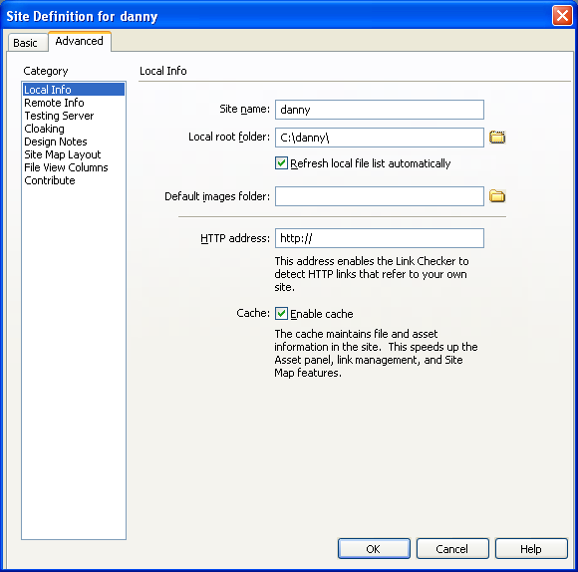

- Select Remote Info from the list on the left, and then select FTP as the access method.  - Fill in the FTP host as shown.  - Fill in the host directory as /tnn where nn is your own site number.  - Fill in the Login box as shown.  - Enter the password as "chang3me". | 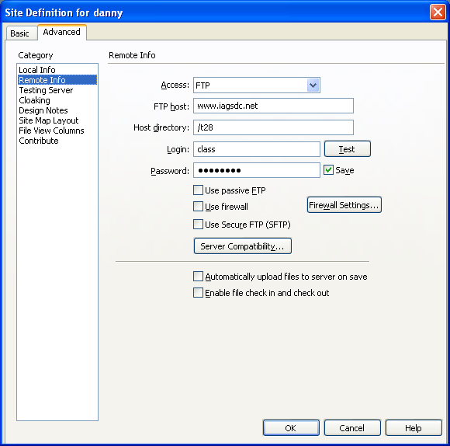
Click the TEST button.  You should receive the message shown to the right. If not, re-check your configuration. | 